**SAVITRIBAI PHULE PUNE UNIVERSITY**



**A MINI PROJECT REPORT ON**

"The Stock Market Predictor”

**Submitted by**

**Name : Shweta Gupta (48)**

**CLASS: BE DIV:B**

## Under the Guidance of

Prof Mrs. Jyoti Raghvan



## DEPARTMENT OF COMPUTER ENGINEERING

**RMD SINHGAD SCHOOL OF ENGINEERING**

WARJE, PUNE 411058

**2023 - 2024**



## DEPARTMENT OF COMPUTER ENGINEERING

**RMD SINHGAD SCHOOL OF ENGINEERING**

WARJE, PUNE 411058

# CERTIFICATE

This is to certify that the project report entitles **“The Stock Market Predictor”** *Submitted by*

Name: **Shweta Gupta(48)**

It is a bonafide work carried out by them under the supervision of Prof. Jyoti Raghvan. And it is submitted towards the partial fulfillment of the requirement of University of Pune for Fourth Year.

**(Prof** Jyoti Raghvan.**) (Prof. Vina M. Lomte)**

Guide Head,

Department of Computer Engineering Department of Computer Engineering

Place: Date:

**(Dr. V. V. Dixit)**

Principal,

RMD Sinhgad School of Engineering Pune – 58

## I

**Certificate by Guide**

This is to certify that Miss Shweta Gupta has completed the MINI Project work under my guidance and supervision and that, I have verified the work for its originality in documentation, problem statement, implementation and results presented in the Project. Any reproduction of other necessary work is with the prior permission and has given due ownership and included in the references.

Place:

Date:

Signature of Guide

**(Prof.** Jyoti Raghvan.**)**

## II ACKNOWLEDGEMENT

It is our pleasure to acknowledge sense of gratitude to all those who helped us in making this Mini Project.

We thank our Mini Project Guide **Prof.** Jyoti Raghvan.for helping us and providing all necessary information regarding our project.

We are also thankful to **Prof. Vina M. Lomte (Head - Department of Computer Engineering)** for providing us the required facilities and helping us while carrying out this project work.

Finally we wish to thank all our teachers and friends for their constructive comments, suggestions and criticism and all those directly or indirectly helped us in completing this Miniproject.

**Student Name: Shraddha Debadwar(47)**

**Shweta Gupta(48)**

**Sneha Tambare(49)**

**III**

## ABSTRACT

The "Stock Market Prediction" project is designed Stock price forecasting is a popular and important topic in financial and academic studies. Share market is a volatile place for predicting since there are no significant rules to estimate or predict the price of a share in the share market. Many methods like technical analysis, fundamental analysis, time series analysis and statistical analysis etc. are used to predict the price in tie share market but none of these methods are proved as a consistently acceptable prediction tool. In this paper, we implemented a Random Forest approach to predict stock market prices.

 Random Forests are very effectively implemented in forecasting stock prices, returns, and stock modeling. We outline the design of the Random Forest with its salient features and customizable parameters. We focus on a certain group of parameters with a relatively significant impact on the share price of a company. With the help of sentiment analysis, we found the polarity score of the new article and that helped in forecasting accurate result. Although share market can never be predicted with hundred per-cent accuracy due to its vague domain, this paper aims at proving the efficiency of Random Forest for forecasting the stock prices.

Stock market is a very volatile in-deterministic system with vast number of factors influencing the direction of trend on varying scales and multiple layers. Efficient Market Hypothesis (EMH) states that the market is unbeatable. This makes predicting the uptrend or downtrend a very challenging task. This research aims to combine multiple existing techniques into a much more robust prediction model which can handle various scenarios in which investment can be beneficial. Existing techniques like sentiment analysis or neural network techniques can be too narrow in their approach and can lead to erroneous outcomes for varying scenarios.

|  |  |  |
| --- | --- | --- |
| Sr No. | Contents | Page No. |
| 1) | Introduction | 7 |
| 2) | Objective, Problem Statement and Project Scope | 8 |
| 3) | System Architecture | 9 |
| 4) | System Requirement | 10 |
| 5) | Program and Implementations | 12 |
| 6) | Conclusion | 18 |

## 1.INTRODUCTION

## Stock market prediction has been a significant area of research in Machine Learning Machine learning algorithms such as regression, classifier, and support vector machine (SVM) help predict the stock market. This article presents a simple implementation of analysing and forecasting stock market prediction using machine learning. The case study focuses on a popular online retail store, and Random Forest is a powerful tree-based technique for predicting stock prices.

The stock market is the collection of markets where stocks and other securities are bought and sold by investors. Publicly traded companies offer shares of ownership to the public, and those shares can be bought and sold on the stock market. Investors can make money by buying shares of a company at a low price and selling them at a higher price. The stock market is a key component of the global economy, providing businesses with funding for growth and expansion. It is also a popular way for individuals to invest and grow their wealth over time.

The Adjusted Close Value reflects the stock’s value after dividends have been declared (too technical!). Furthermore, the total volume of the stocks in the market is provided. With this information, it is up to the job of a Machine Learning/Data Scientist to look at the data and develop different algorithms that may extract patterns from the historical data of the Microsoft Corporation.

# Objectives

* Stock markets help companies to raise capital.
* It helps generate personal wealth.
* Stock markets serve as an indicator of the state of the economy.
* It is a widely used source for people to invest money in companies with high growth potential.

# Problem Statement

To analyzing the company’s future profitability on the basis of its current business environment and financial performance. Technical Analysis, on the other hand, includes reading the charts and using statistical figures to identify the trends in the stock market.

# Project Scope

* With an understanding of what stock and the stock market is, let’s understand why people fascinate by a Machine Learning model that can predict the stock price. A Machine Learning model predicts the value of an observation based on several inputs that are predictors.
* The stock market is working similarly, i.e., based on several inputs, the stock price fluctuates. However, the bone of contention is that, unlike other problems that generally are predicted, the predictions of stock prices are rather complicated as it is often prey to the butterfly effect. Anything, any event in the outside world, can influence the price of the stock.
* These include political events, economic news, competitors or related stock movements, and other challenging to capture concepts such as rumor, anxiety, and other psychological factors. Capturing all these inputs makes stock market prediction challenging and Machine Learning a potential candidate for it.
* It can take a large number of inputs and assess the patterns and their relation to a dependent variable (the stock price).

# SYSTEM ARCHITECTURE

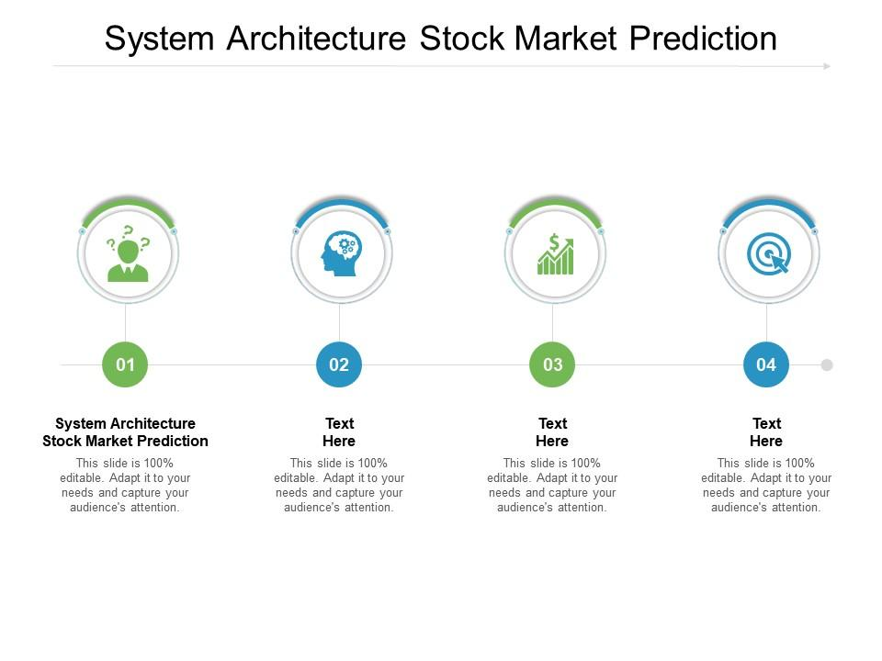**2.SYSTEM REQUIREMENT**

## Hardware Requirements

I3 processor 4 GB RAM

60 GB HDD

**Software Requirements** Windows Operating System Python

Libraries

Jupyter Notebook Python IDE

**Implementation**

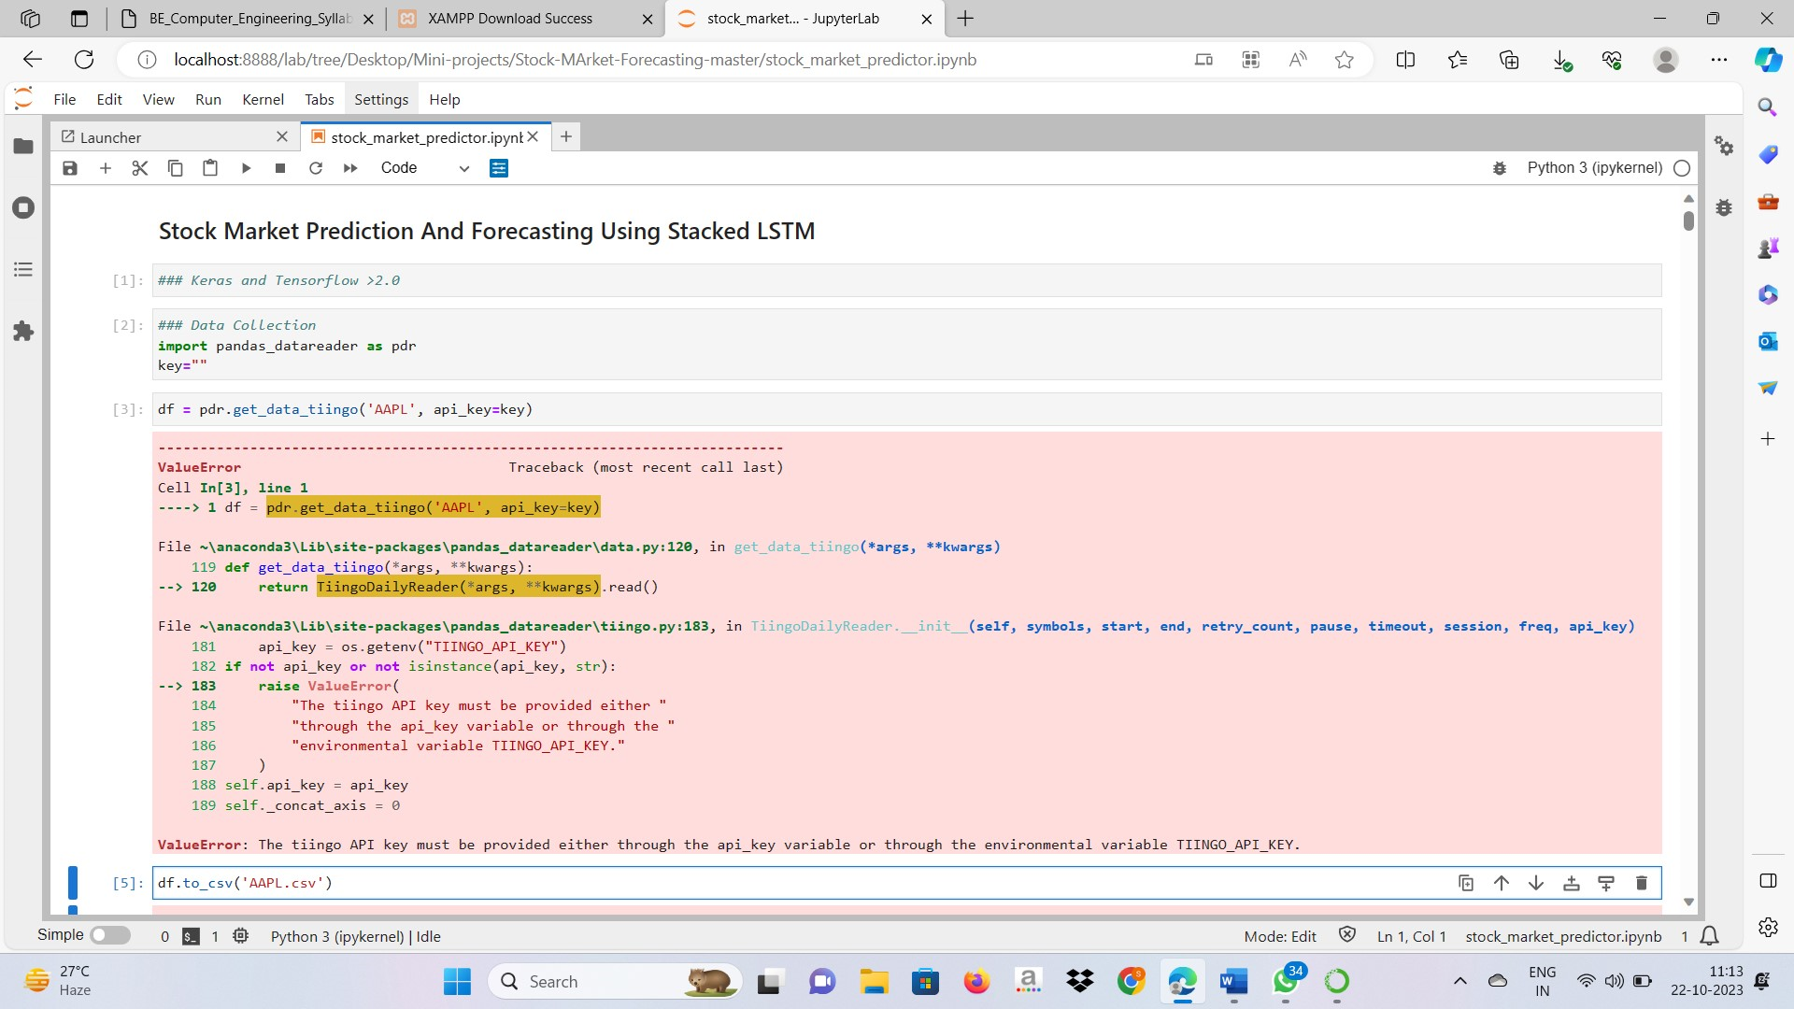

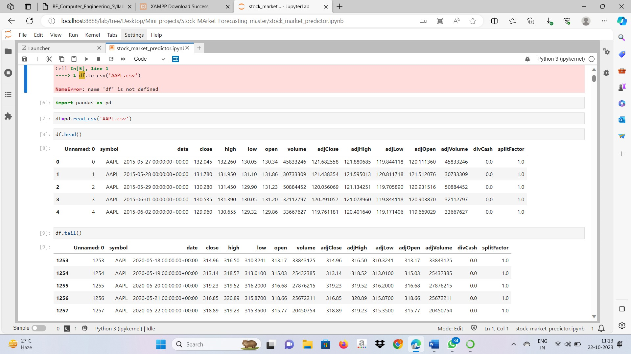

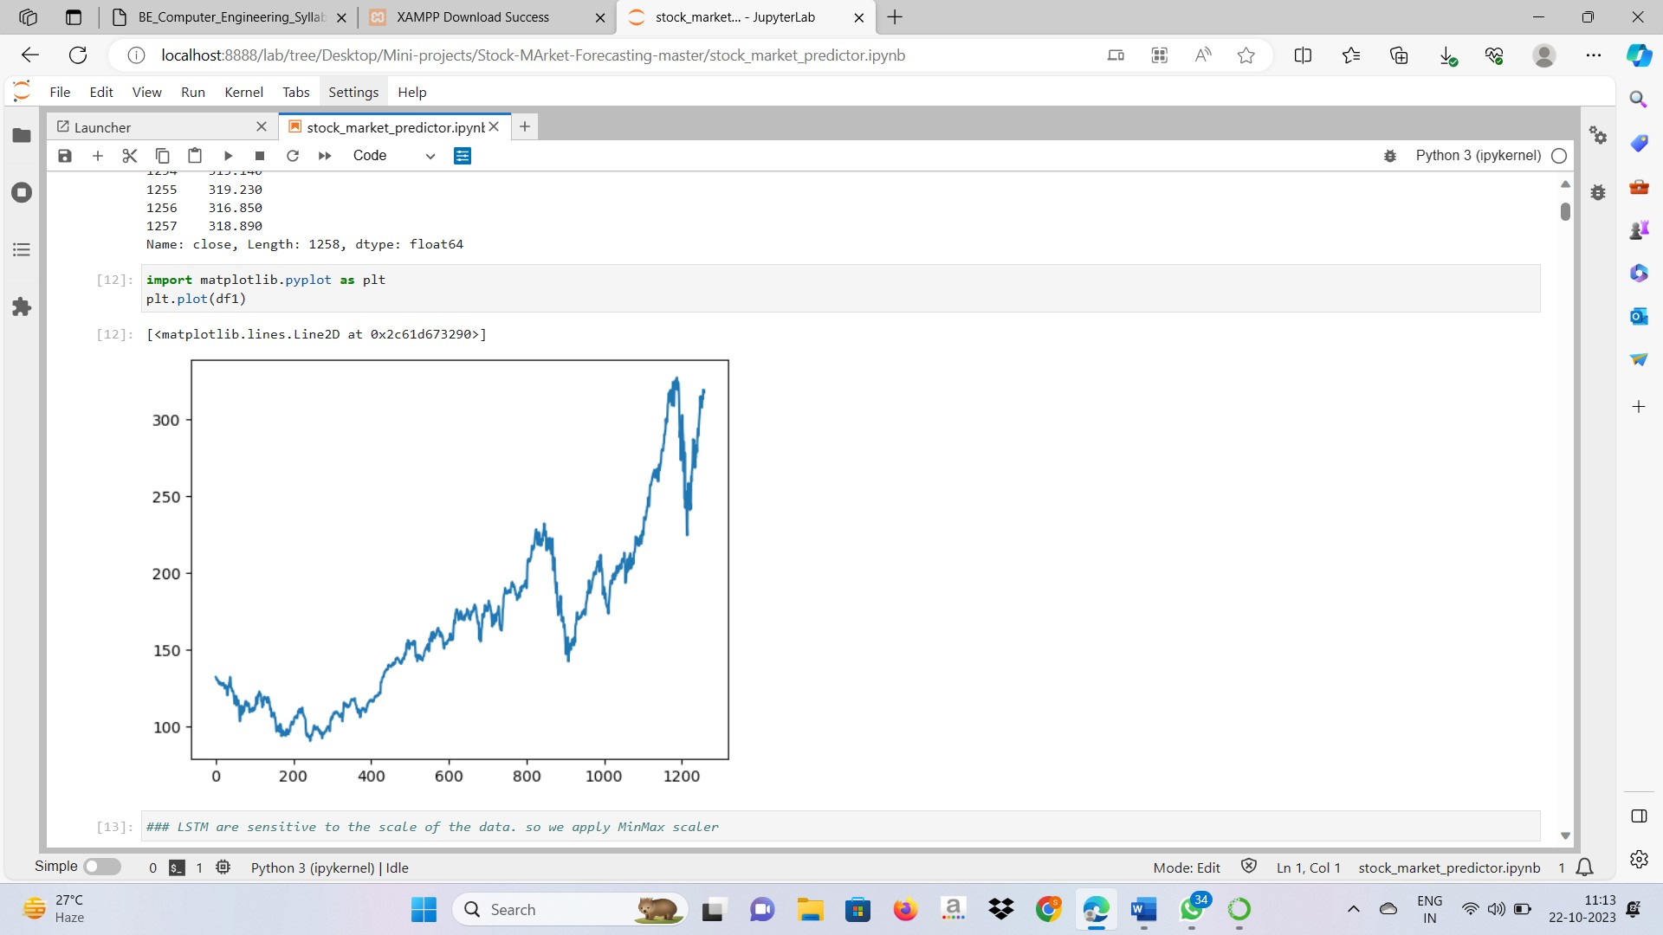

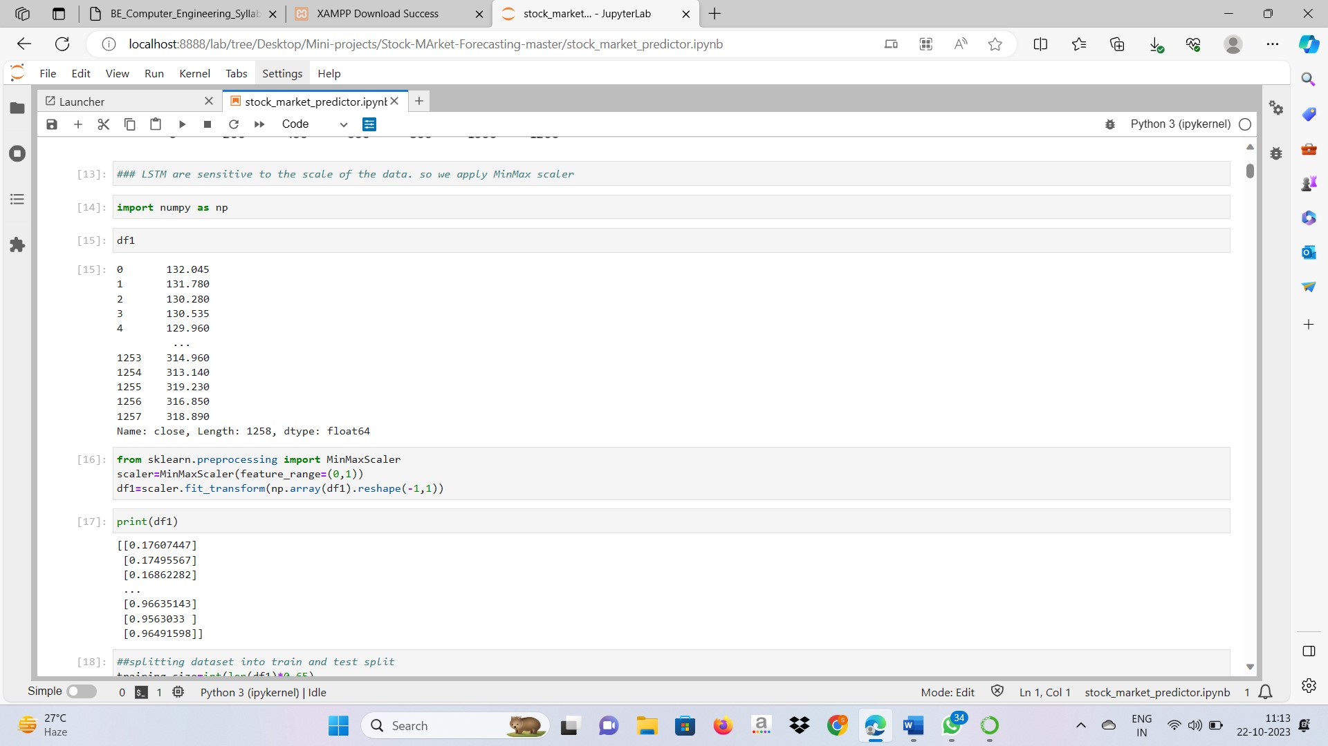

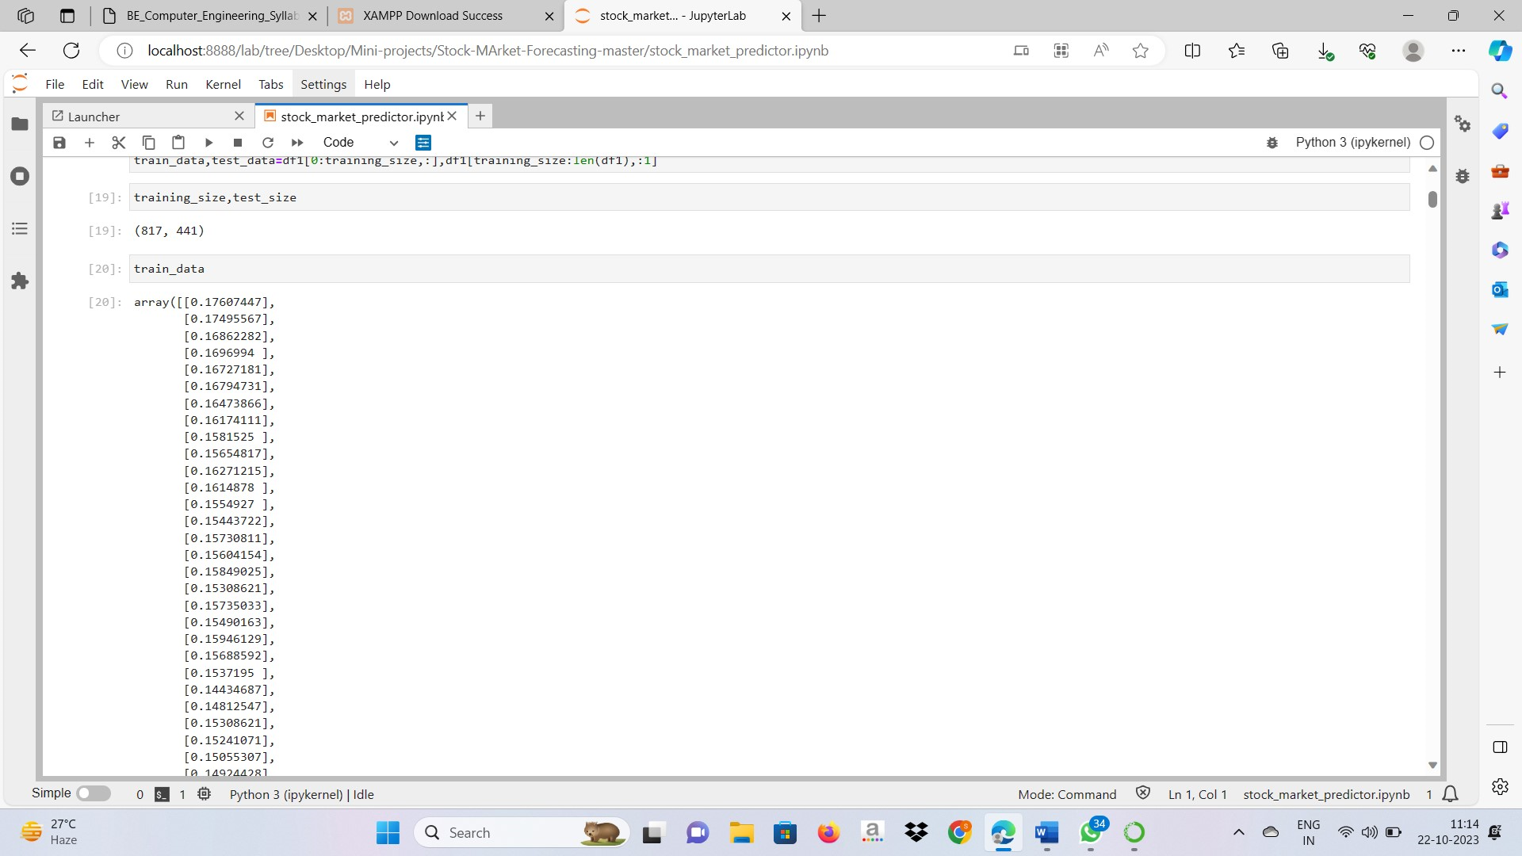

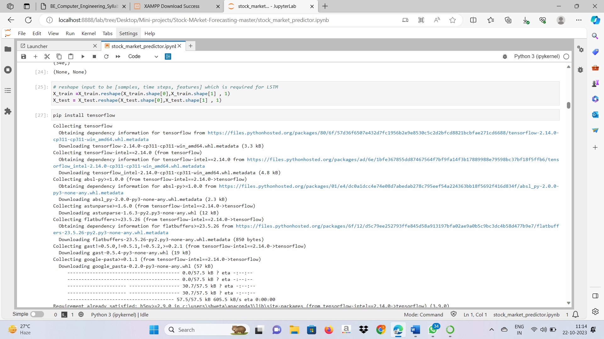

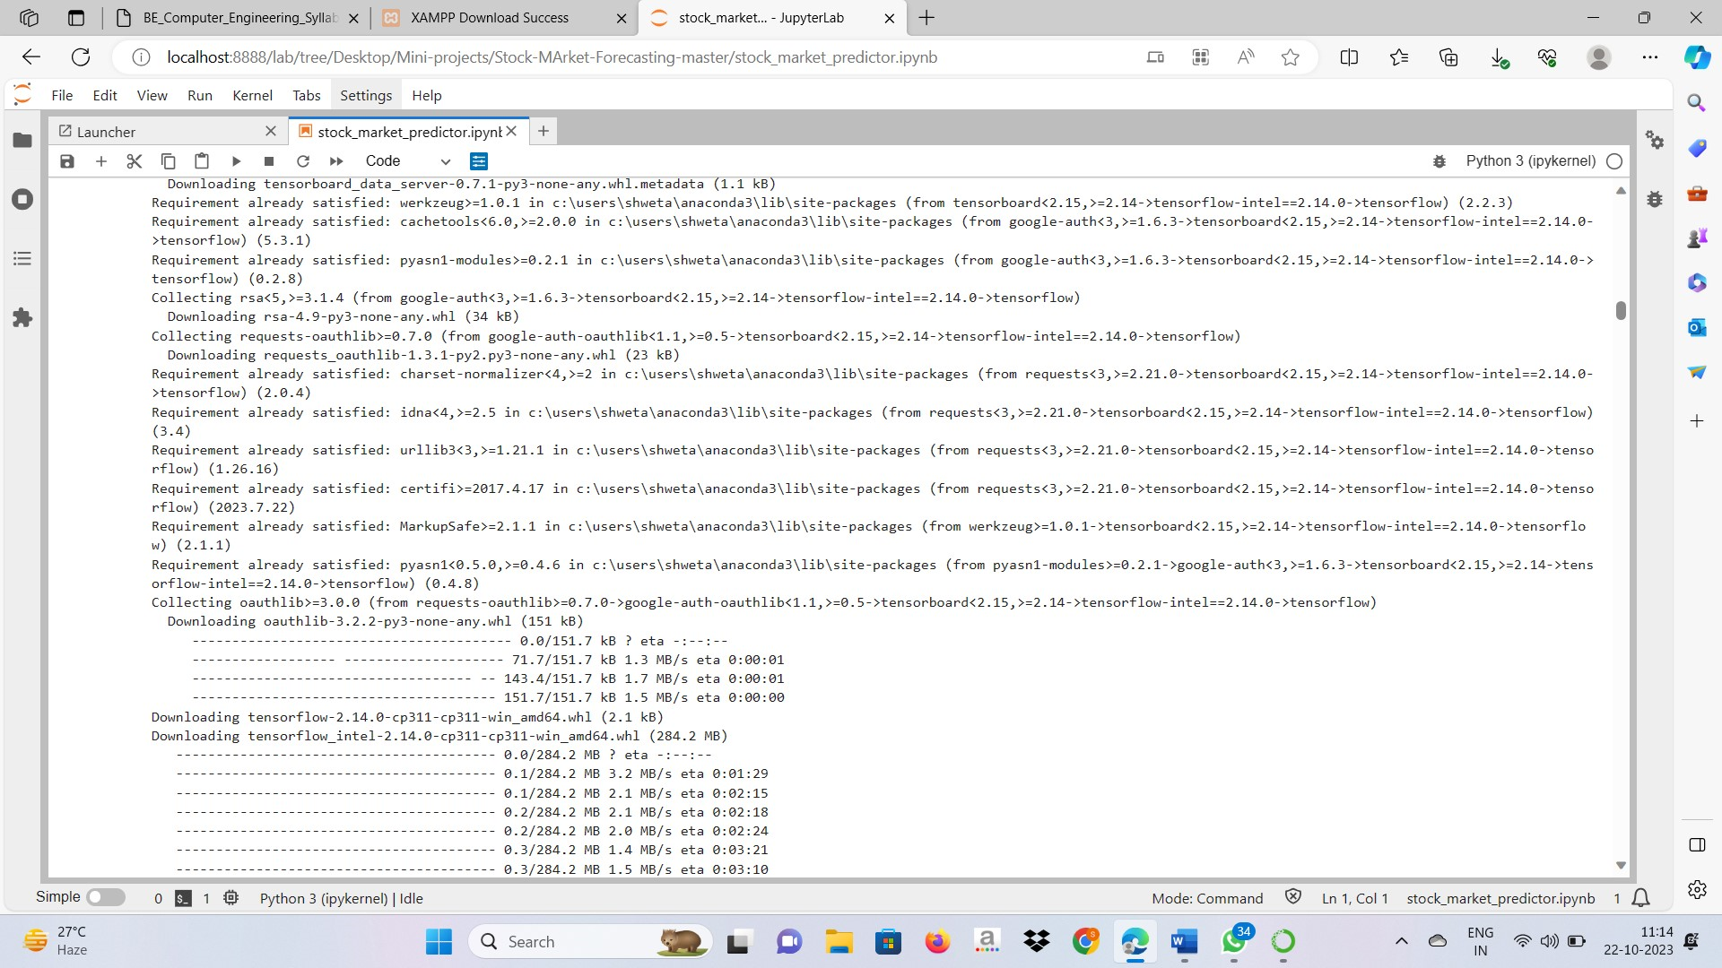

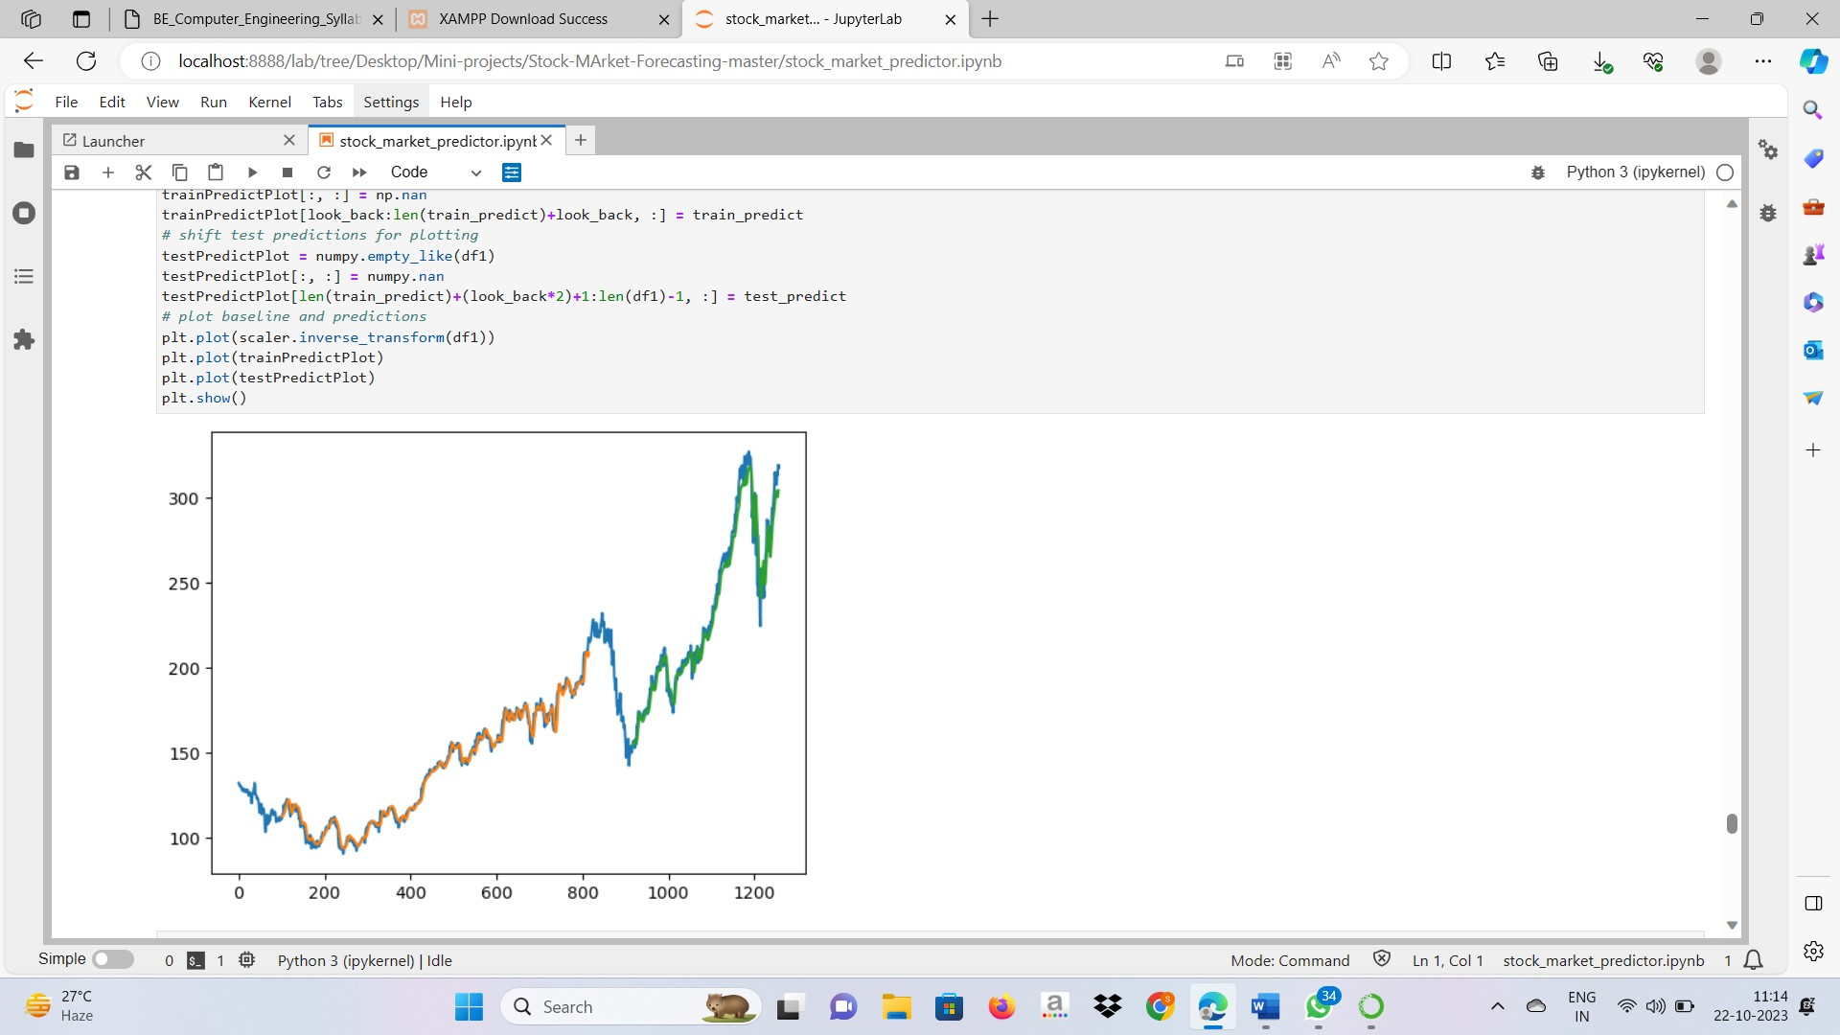

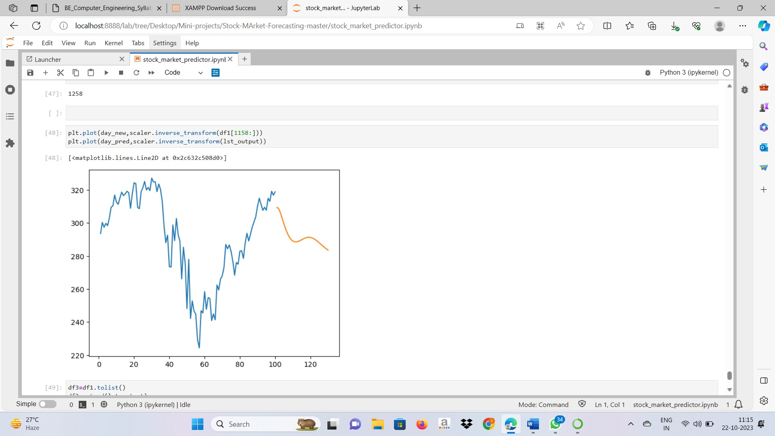

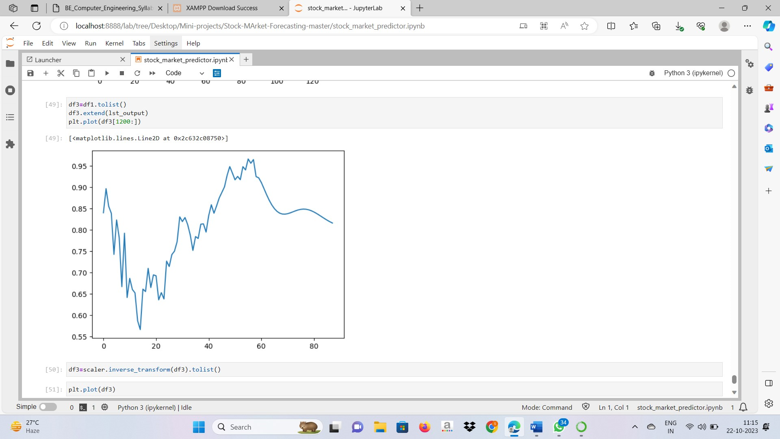

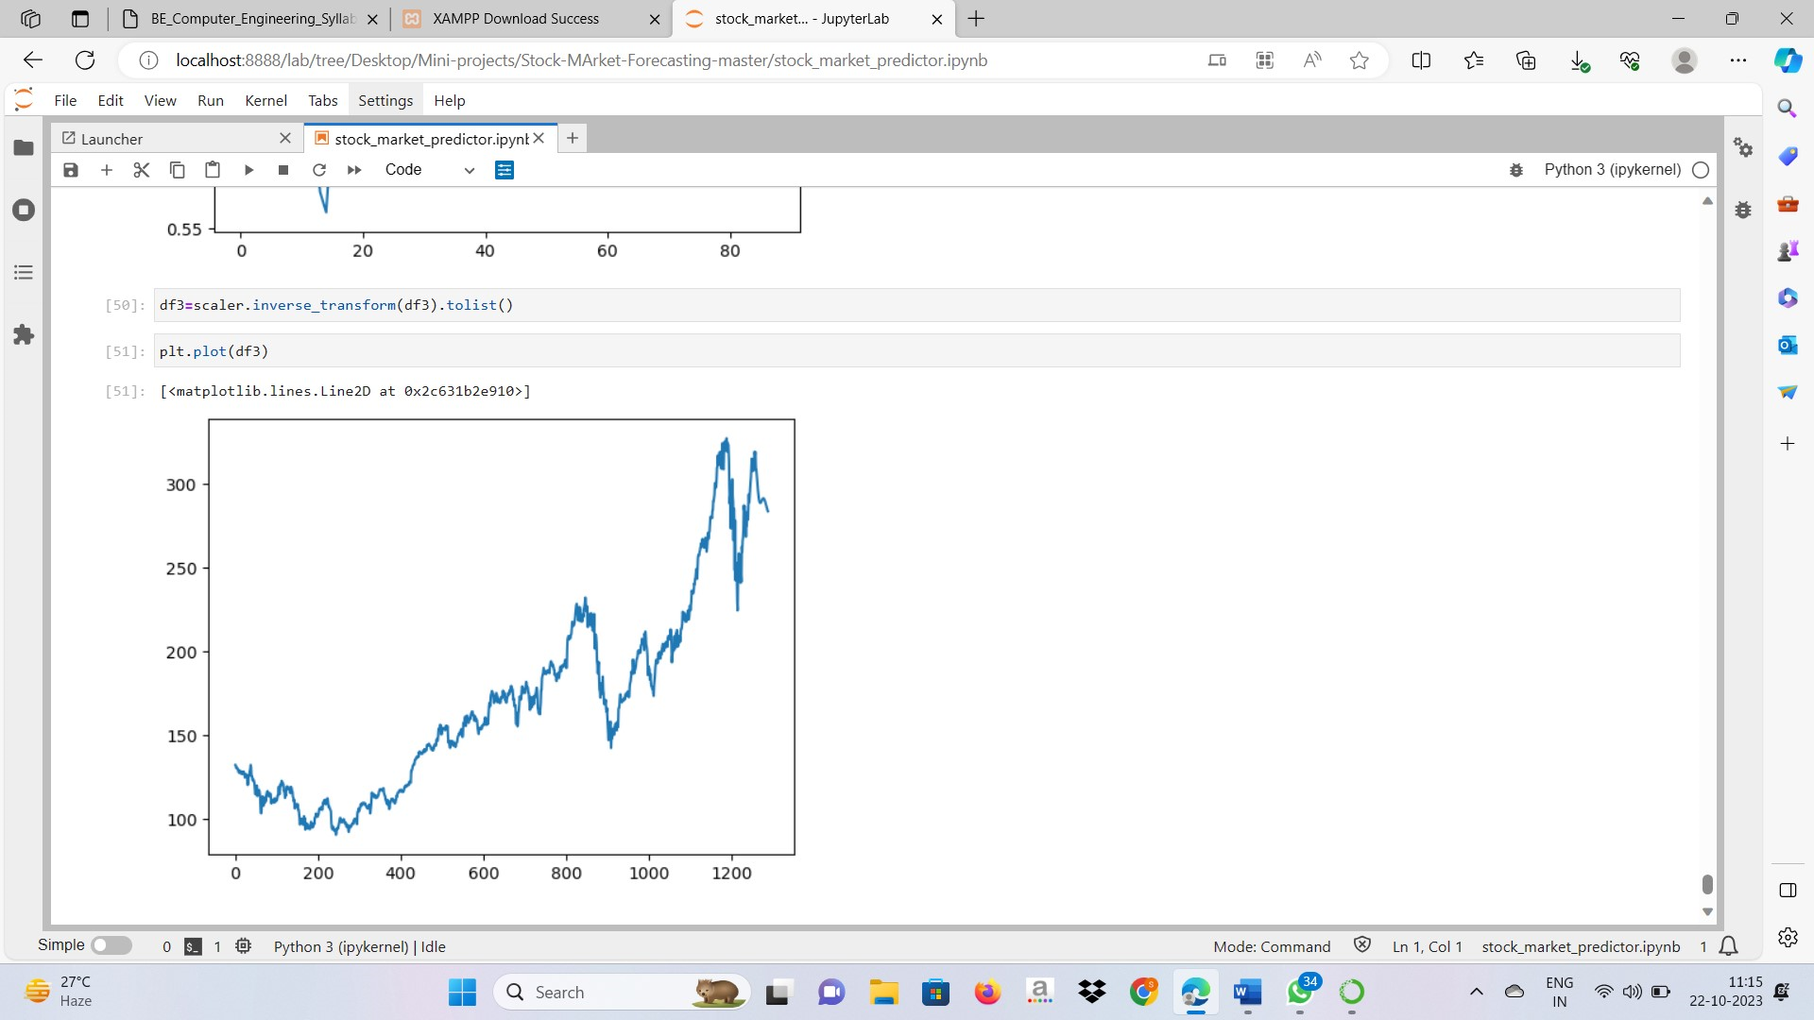

**Conclusion**

In this project, we successfully developed a machine learning model, the "The Stock Market Predictor LSTM and SMA and Neural Network, on the finance dataset. The techniques have shown an improvement in the accuracy of predictions, thereby yielding positive results. Use of recently introduced machine learning techniques in the prediction of stocks have yielded promising results and thereby marked the use of them in profitable exchange schemes.